|  |  |  |  |  |  |  |  |  |
| --- | --- | --- | --- | --- | --- | --- | --- | --- |
| |  | | --- | | Sony XQD 64GB Series G memory card | | Product image thumb |  |  |  |  |  | | --- | --- | --- | --- | | Product image thumb | Product image thumb |  |  | |  | **Specifications:**  Storage capacity up to 64GB  Read and write speeds up to 440 MB/s  Withstands temperatures from -13 to 149°F  Shockproof, X-ray proof and magnet proof  **Price: 119$** |

**Overview:**

**Sony XQD 64GB Series G|memory card FOTOLAB**

Sony's XQD 64GB G Series memory card is designed for professional photographers and videographers. Like other Sony memory cards, this memory card is shockproof, X-ray proof and magnet proof. It can also withstand temperatures from -13 to 149°F allowing you to carry it in harsh environments. Besides, it is also resistant to exposure to intense UV light.

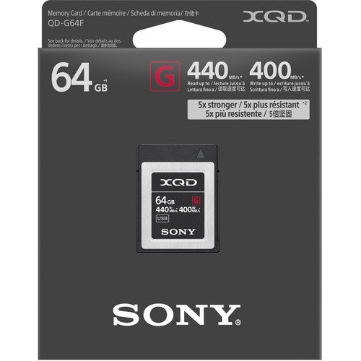

The memory card provides up to 64GB of storage capacity with read and write speeds of up to 440 MB/s allowing for 4K video recording and storage of up to 200 continuous images.